Motor Vehicle Accident Reporting (Company Vehicles)

A motor vehicle collision can be a stressful experience for everyone involved. It can be easy to feel overwhelmed and confused after a collision, but it is important that you stay calm.
There are a number of critical post-crash steps you need to keep in mind—steps that can help save lives, keep those involved safe and assist in simplifying your insurance claims process. Remember to do the following:
- Step 1: Stop your vehicle. If you are involved in an accident and don't stop, you may be subject to criminal prosecution.
- Step 2: Call for medical aid, if necessary.
- Step 3: If medical aid is not necessary, call the authorities for any accidents or incidents that occur on public roadways, so that the accident is reported and recorded with a police report. If an accident occurs on private property that causes property damage, speak with the owner of the property and your supervisor to determine next steps, but always document the damage by taking pictures and fill out the accident form to record what happened.
- Step 4: Follow the instructions given to you by the 911 operator. Police or emergency personnel will arrive as soon as possible. Do not try to move anyone injured in the accident, as you may aggravate their injuries.
- Step 5: If it is safe to do so, get out of your car. If you have access to a digital camera or cellphone, take pictures of the scene.
- Step 6: When it is safe, move your vehicle to the side of the road and out of traffic. If your vehicle cannot be driven, turn on your hazard lights or use cones, warning triangles or flares, as appropriate.
- Step 7: Use the attached form to record as much information about the accident as possible.
- Step 8: Turn in all your accident documentation and pictures to your supervisor.
Remember, as difficult as it may seem, it is important that you remain claim. Refrain from arguing with other drivers and passengers. What’s more, do not voluntarily assume liability or take responsibility, sign statements regarding fault or promise to pay for damage at the scene of the accident.

YOUR INFORMATION
^{Your name:}  Click or tap here to enter text. | ^{Your driver’s license number:}  Click or tap here to enter text. |  | Your full address and phone number:  Click or tap here to enter text.
Vehicle owner’s name (if different from driver)Click or tap here to enter text.: | Owner’s full address and phone number (if different from driver):  Click or tap here to enter text.
YOUR VEHICLE INFORMATION
^{Year make and model:}  Click or tap here to enter text. | ^{Mileage:}  Click or tap here to enter text. |  | ^{Color:}  Click or tap here to enter text.
^{Plate number and state:}  Click or tap here to enter text. | Vehicle identification number (VIN):  Click or tap here to enter text. |  | Was the vehicle in proper driving condition?  Click or tap here to enter text.
YOUR INSURANCE INFORMATION
^{Insurance company:}  Click or tap here to enter text. | ^{Phone number:}  Click or tap here to enter text. |  | Policy number and expiration date:  Click or tap here to enter text.
YOUR PASSENGERS
List the full name and position of every passenger (front, back seat):  Click or tap here to enter text. |  | Describe any passenger injuries:  Click or tap here to enter text.

THE OTHER DRIVER’S INFORMATION
^{Other driver’s name:}  Click or tap here to enter text. | ^{Other driver’s license number:}  Click or tap here to enter text. |  | Other driver’s full address and phone number:  Click or tap here to enter text.
Vehicle owner’s name (if different from other driver):  Click or tap here to enter text. | Owner’s full address and phone number (if different from other driver):  Click or tap here to enter text.
OTHER VEHICLE INFORMATION
^{Year make and model:}  Click or tap here to enter text. | ^{Mileage:}  Click or tap here to enter text. |  | ^{Color:}  Click or tap here to enter text.
^{Plate number and state:} Click or tap here to enter text. | Vehicle identification number (VIN):  Click or tap here to enter text. |  | Was the vehicle in proper driving condition?  Click or tap here to enter text.
OTHER DRIVER’S INSURANCE INFORMATION
^{Insurance company:}  Click or tap here to enter text. | ^{Phone number:}  Click or tap here to enter text. |  | Policy number and expiration date:  Click or tap here to enter text.
OTHER VEHICLE’S PASSENGERS
List the full name and position of every passenger in the other vehicle (front, back seat):  Click or tap here to enter text. |  | Describe any passenger injuries:  Click or tap here to enter text.

ACCIDENT INFORMATION
^{Date and time:}  Click or tap here to enter text. | Estimated speed of your vehicle (mph):  Click or tap here to enter text. |  | ^{Is your vehicle drivable?}  ☐ Yes ☐ No
Location (city, crossroads, landmarks)  Click or tap here to enter text. | Estimated speed of the other vehicle (mph):  Click or tap here to enter text. |  | ^{Is the other vehicle drivable?}  ☐ Yes ☐ No
Describe the damage to your vehicle:  Click or tap here to enter text. |  | Describe the damage to the other vehicle:  Click or tap here to enter text.
Click or tap here to enter text.^{Road conditions:}  ☐ Icy  ☐ Wet  ☐ Clear  ☐ Debris  ☐ Other:  Click or tap here to enter text. | ^{Weather conditions:}  ☐ Fog  ☐ Snow  ☐ Hail  ☐ Rain  ☐ Other:  Click or tap here to enter text. |  | ^{Lighting conditions:}  ☐ Dawn  ☐ Dusk  ☐ Day  ☐ Night  ☐ Other:  Click or tap here to enter text.
^{Other details of the accident:}
Click or tap here to enter text.
COLLISION WITNESSES
^{Name:}  Click or tap here to enter text. | ^{Phone number:}  Click or tap here to enter text. |  | ^{Address:}  Click or tap here to enter text.
^{Email:}
Click or tap here to enter text.
^{Name:}  Click or tap here to enter text. | ^{Phone number:}  Click or tap here to enter text. |  | ^{Address:}  Click or tap here to enter text.
^{Email:}
Click or tap here to enter text.
^{Name:}  Click or tap here to enter text. | ^{Phone number:}  Click or tap here to enter text. |  | ^{Address:}  Click or tap here to enter text.
^{Email:}
Click or tap here to enter text.

ACCIDENT DIAGRAMS (DRAW OUT)
Highway ramp
Four-way intersection
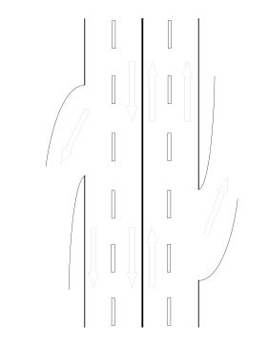 | 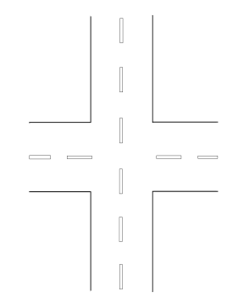
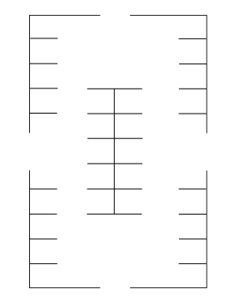  Parking lot | 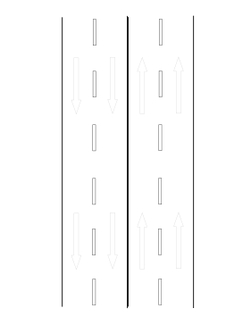  Two-lane highway or road
Legend (Please use the following symbols to complete the collision diagram.)
Your Vehicle Other Vehicles (Numbered Successively) Pedestrian Traffic Signal Traffic Sign (Indicate Type)

ATTENDING POLICE OFFICER
^{Name:}  Click or tap here to enter text. | ^{Badge number:}  Click or tap here to enter text. | ^{Phone number:}  Click or tap here to enter text.
TOW TRUCK OPERATOR
^{Driver’s name:}  Click or tap here to enter text. | ^{Company:}  Click or tap here to enter text. | ^{Truck number:}  Click or tap here to enter text.
^{Phone number:}  Click or tap here to enter text. | ^{Vehicle towed to:}  Click or tap here to enter text. | ^{Cost:}  Click or tap here to enter text.

